Patient Health Monitoring Data Pipeline Using AWS
Prepared By: Keshab Rai
Project: AWS Healthcare ETL Pipeline
Date: May 20, 2026

Created S3 bucket named patient-health-monitoring with raw, processed, and rejected folders for storing healthcare data.
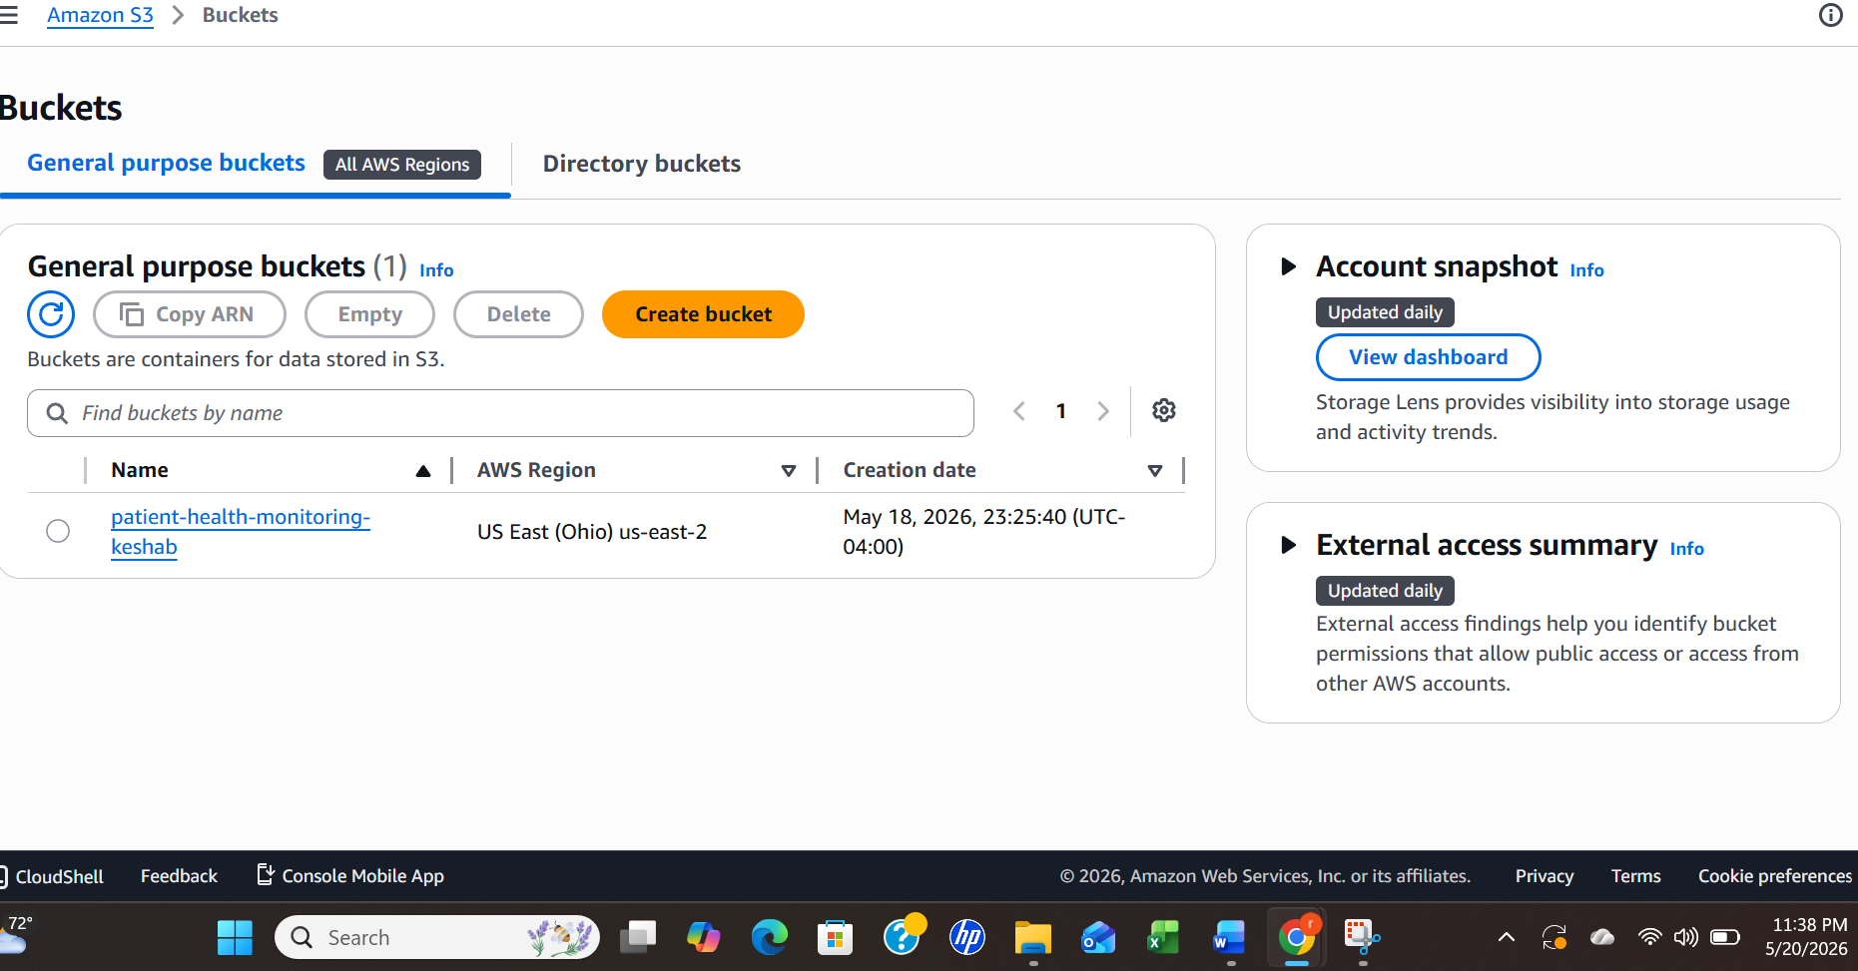
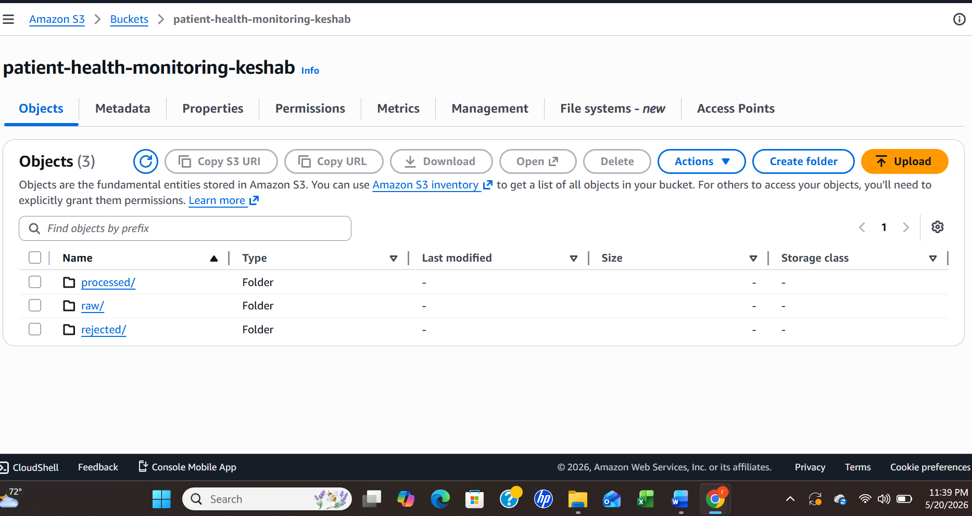

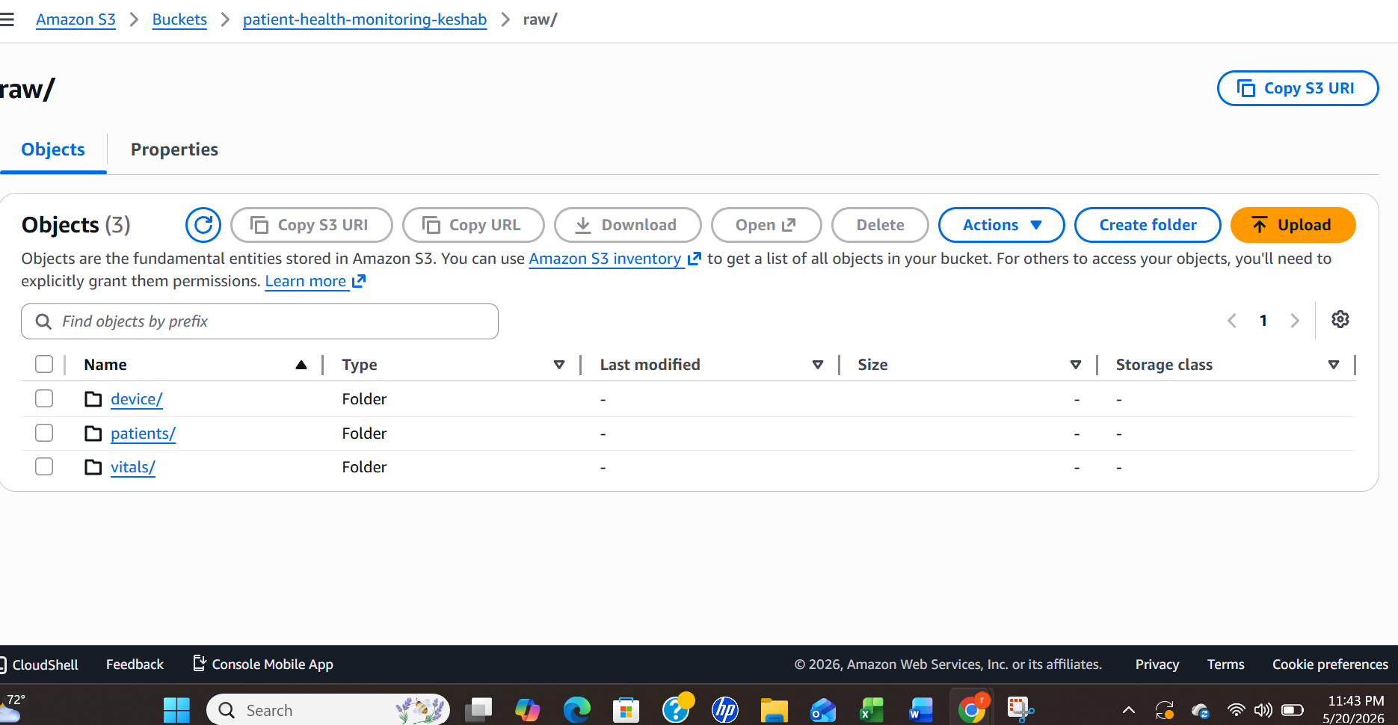

Glue crawler automatically detected schema and created tables in healthcare_db. 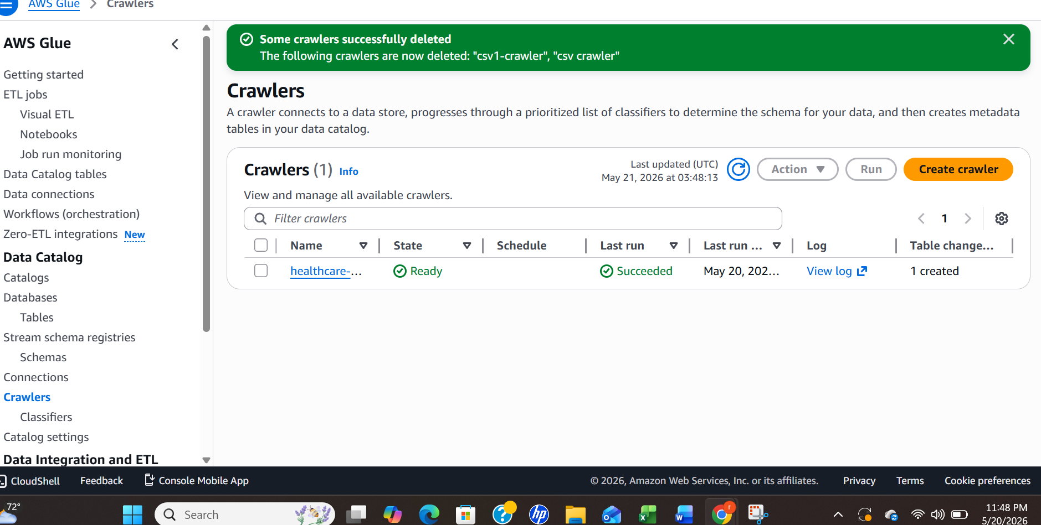

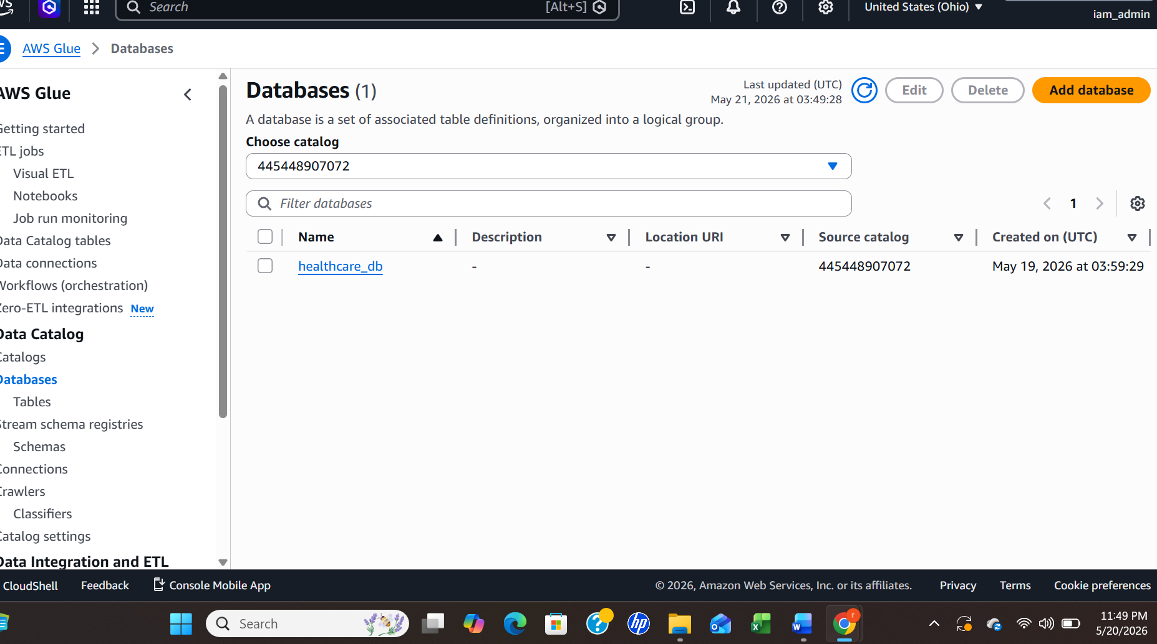
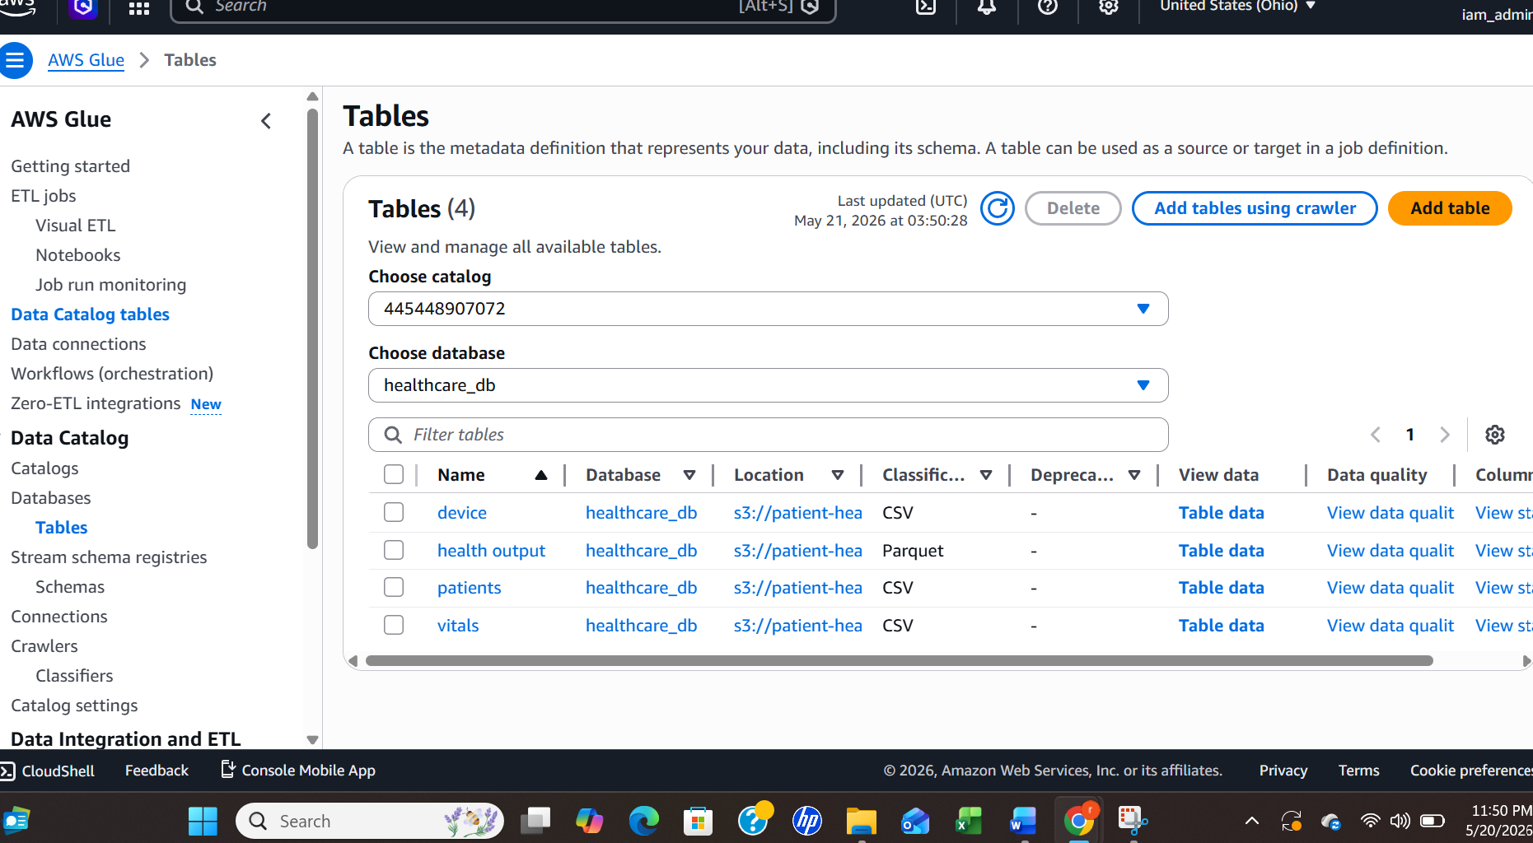

Visual ETL pipeline created using AWS Glue Studio.
The pipeline performs:
- null removal
- duplicate removal
- derived column creation
- joins
- field selection
- parquet output generation
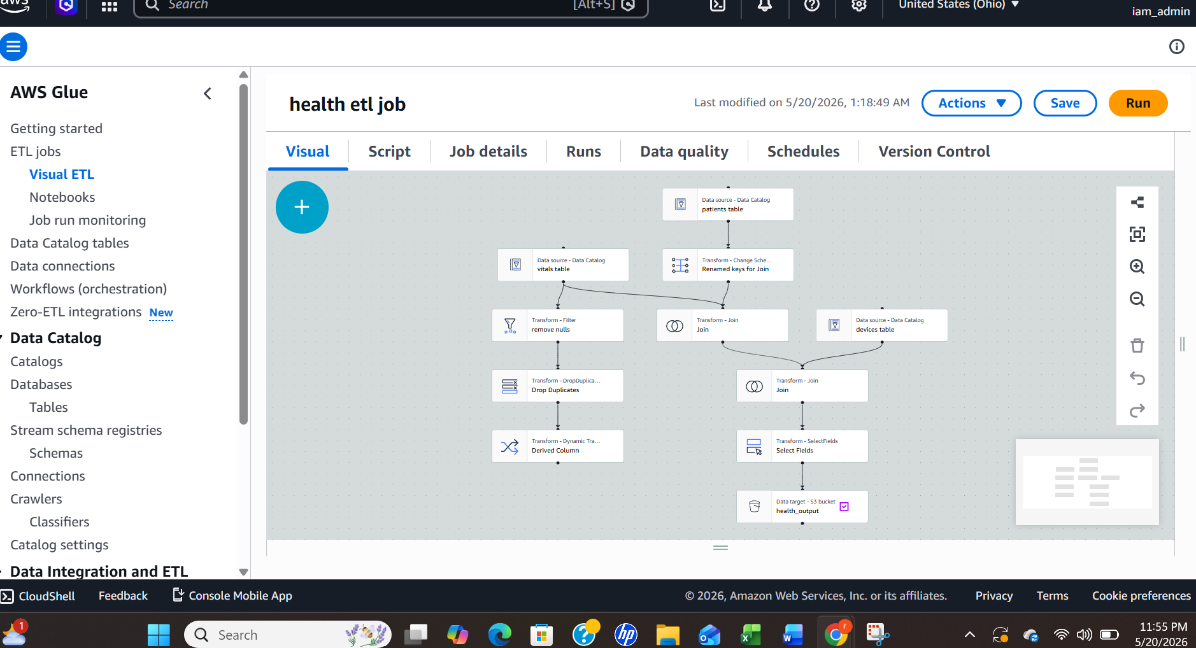

Derived column health_status was created using AWS Glue Studio SQL expression builder.
CASE
WHEN oxygen_level < 90 THEN 'Critical'
WHEN temperature > 100 THEN 'Fever'
WHEN heart_rate > 100 THEN 'High Risk'
ELSE 'Normal'
END
Processed healthcare data stored in Parquet format in S3 processed/reports folder. 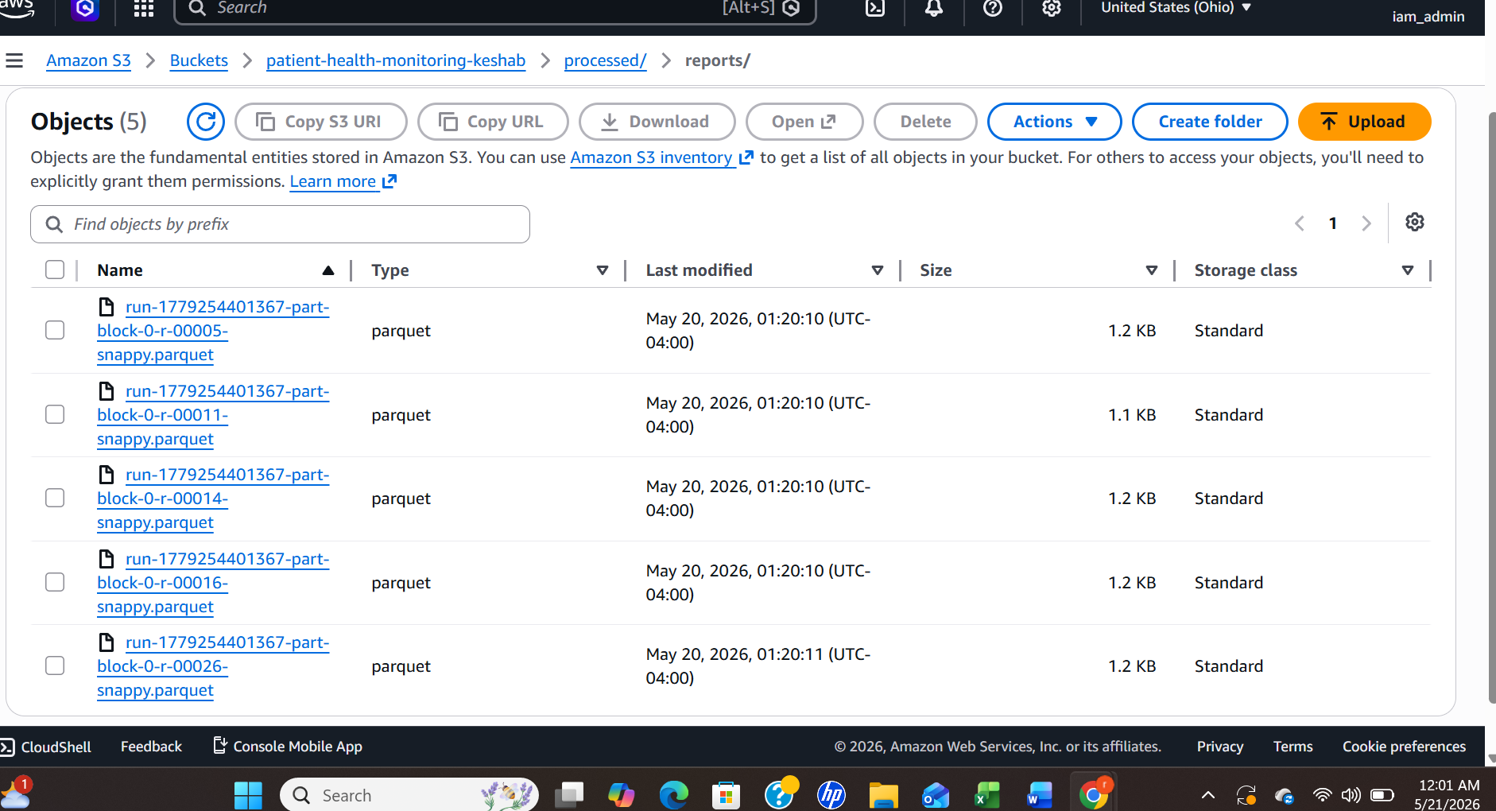

Challenges:
- col0 unresolved column issue
- CSV header mismatch
- join configuration issues

Solutions:
- corrected CSV formatting
- reran Glue crawler
- enabled header detection
Conclusion
Successfully built a healthcare ETL pipeline using AWS Glue Studio without coding. The project cleans, transforms, validates, joins, and stores healthcare monitoring data using AWS services.

